High Albedo: Twisted Skies
The Guide

For Version 1.2

WARNING: This guide is for a program that is under constant development. It may not include all changes. This guide is NOT definitive, there are plenty of undocumented features.
Getting Started

Thank you for downloading High Albedo! This guide is designed to help you get into the game quickly, so the most important contents for getting started are presented first. Anything else can wait.

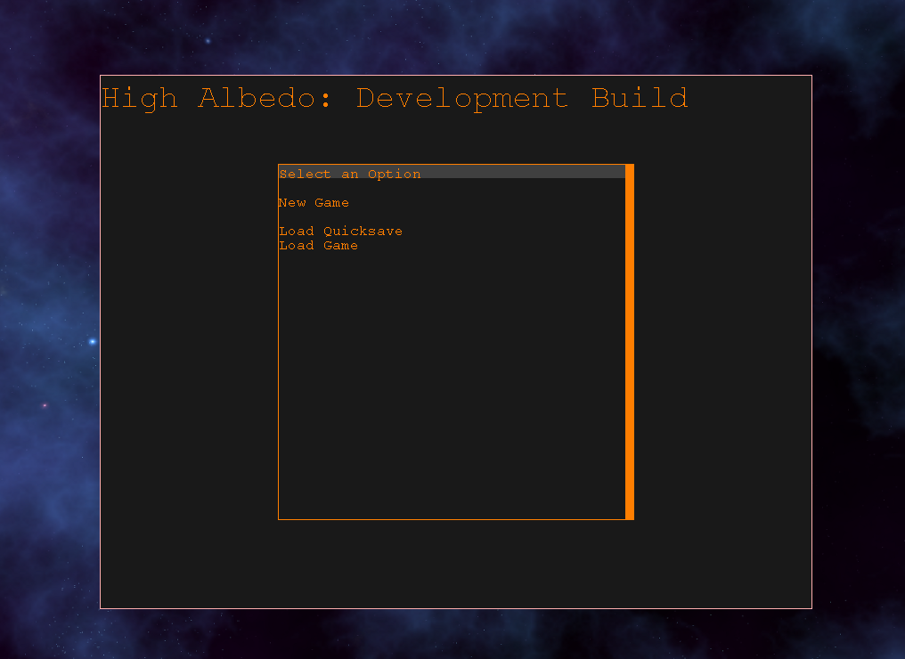
This is the screen you will see upon starting High Albedo. For this guide, all screen shots are in 1024 x 768 resolution to conserve space in the document.

Here are your options:
- New Game – Starts a new game.
- Load Quicksave – Loads the quicksave, which is saved by pressing F11 (and can be loaded by pressing F12 once you're in the actual game).
- Load Game – Loads any game from the save folder.

Once you are in-game, you can get back to this menu by pressing F1. You will also see three new options.
- Save Game – Allows you to save into slots, a new slot is added whenever you fill the one before it.
- Settings – Lets you adjust some aspects of your game
- Planet detail – High Albedo generates procedural planets, and this task can take some time on slower machines. If the generation times are too long, you can shorten them significantly by reducing detail. Alternatively, you can increase the detail, if you are willing to wait.
- Enable Sound Effects – Toggles the weapon, engine, and other sound effects.
- Enable Music – Toggles music.
- Resume – Return to the game.

Your New Game

When you start a new game, you will be in the Cab (as defined in the universe file). This ship has a pretty small cargo hold and an uninspiring selection of weapons, but it is pretty damn fast!

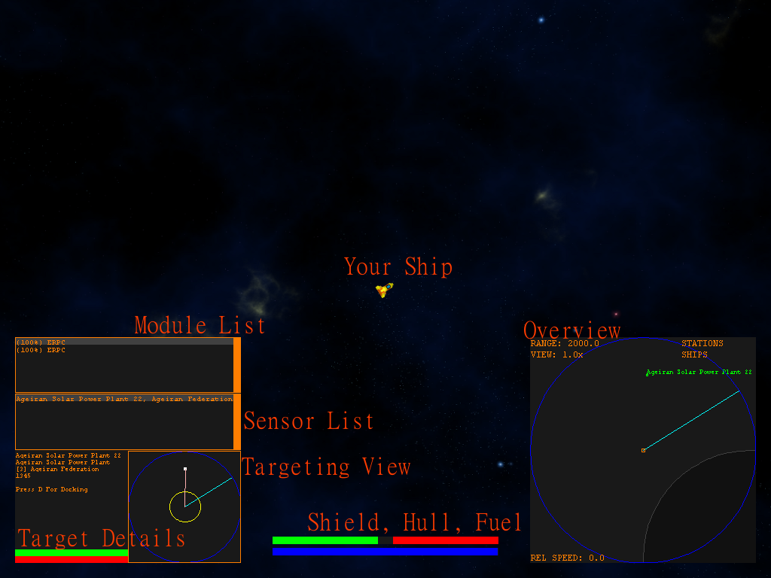
Here's a crash course in your UI.
HINT: Pressing F5 will deselect all windows.
- Your Ship – This is your ship! You can turn and thrust by pressing the Arrow keys on your keyboard (left and right steer, up and down thrust forward and reverse). Pressing SPACE will fire all your active weapons.
- HINT: The different windows on your screen have focus! If you click on one, it gets focus, just like in most real display managers. When working in a window, you cannot steer or fire weapons because the window is intercepting those commands. Pressing F5 or clicking in empty space will defocus all windows and return to free flight mode.
- Module List – This lists the equipment fit to your ship. The percentage indicates how ready the equipment is, and must be at 100% to use the module. Modules are activated by pressing SPACE. You can toggle a module on or off by clicking on it in the list.
- Sensor List – This is a list of all nearby ships and stations. You can target a ship by clicking its entry in the list.
- Targeting View – This shows the position of your target, what direction the nose of your ship is facing (cyan line), and the range of the equipment selected in the module list (yellow circle). It is a simplified sensor view for targeting enemies in combat.
- HINT: Pressing R while fighting will target the nearest enemy.
- HINT: You can click on a ship or station in space to target it.
- Target Details – Shows more information about your current target such as the name, the type of ship, the faction it belongs to, and how far away it is.
- Shield, Hull, Fuel – Shows how much of these resources you have left.
- HINT: Fuel is needed to steer and accelerate! Maneuvering in space consumes fuel, and to replenish the fuel supply you need to dock. When docked, your fuel is automatically set to 100%.
- HINT: Hull damage can only be repaired by firing a repair beam at the damaged ship, meaning you need 2 ships to make repairs (one to fire the beam, one to be repaired). Be careful.
- HINT: Shields will regenerate over time.
- Overview – The overview is your primary instrument for viewing the world. It shows the locations of planets, stations, ships, asteroids, and jumpholes in the system.
- HINT: The overview can be filtered. When the overview is focused, pressing PAGE UP will filter out space stations, pressing PAGE DOWN will filter out ships. You can also zoom in and out by pressing the HOME (in) and END (out) keys. Be aware you get diminishing returns at longer ranges.
- HINT: The overview shows which way you are pointing (cyan line) and which way you are traveling (yellow line).

In addition, you can control the rate time passing using the keys 1 – 5. 3 is normal.

So, now that you have an idea how to navigate, how about we make some money?

Making Money

High Albedo is a very complex game with many ways to make money. Here are the basics.
- Trading – Buy low, sell high. Traders can be automated.
- Missions – Given out by talking to NPCs that are at least of neutral standing to you, these can be very challenging.
- Salvaging – Scooping up the freight and weapons dropped by destroyed enemies and selling them.
- Running Stations – You can purchase your own space stations that can produce a profit by producing products from resources you supply it.
- Mining – As of v1.2, you can only mine using space stations. You need to find an asteroid and put a mine on it. Asteroids are usually located in neutral space. In future versions, you will be able to mine using a mining module.

A Trade Run

Lets do a simple trade run. In your new game, dock with the station 'Ageiran Solar Power Plant 22'. To do this, select the station in the sensor list, press F5 (to return to free flight), and press D to dock. The docking sequence is automated.

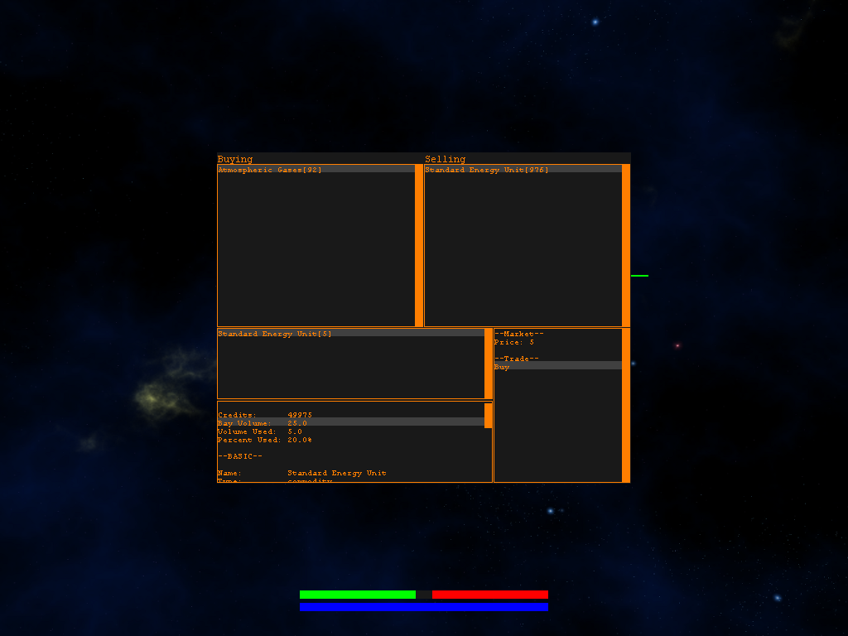

Once docked, you will need to press T to bring up the trade window. You can hide the sensor windows by pressing E and S. You can press those later to get them back.

HINT: Pressing F6 will hide all windows.

This station produces standard energy units. You can see that the station buys atmospheric gases and sells standard energy units. We want to buy some energy. Click on the standard energy unit entry and then click buy.

You will need to enter a quantity to buy. You cab can't carry many, but buying even one is good for this example. You can see information about your cargo bay, (contents, volume used, etc) from the trade window as well.

Once you've entered a quantity, press enter and the trade will attempt. Trades will fail if you don't have the cash to cover the trade, or the station cannot supply you with enough of the product.

HINT: Stations really do convert their resources into products, so they need to be kept supplied to be productive. Stations have limited space to store products and resources.

Now, in free flight mode press D to undock. Once you've undocked, we need to go to another station to sell these. Fortunately, the start system has an MRE factory.

The MRE factory is kind of far away, but we can dock with it using the Property Window. This window lets you see all the ships and stations you own and manage them remotely! Right now you only have 1 ship and no stations, but you can still use the autopilot features.

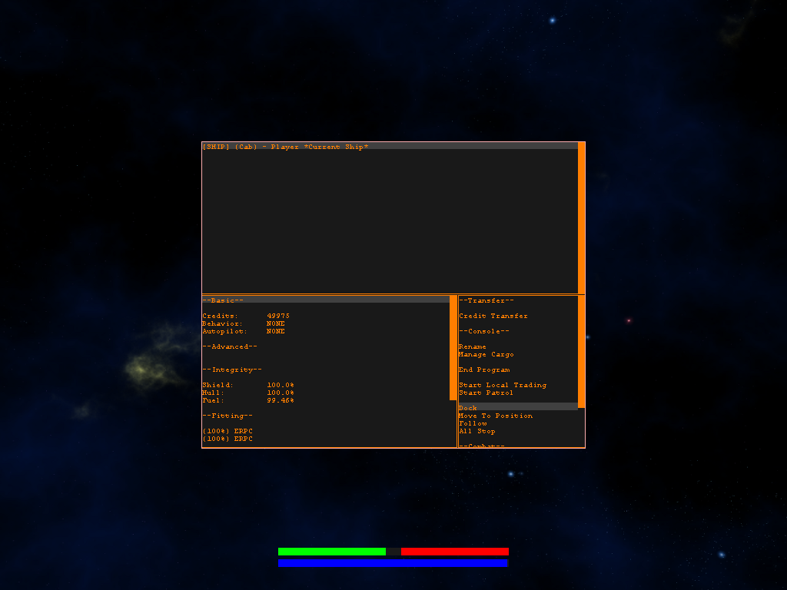

Press P in free flight to bring up the property window, then pick your Cab from the list of things you own at the top.

You'll see information about the selected property on the bottom left, and a list of commands on the bottom right. Although those commands are cool, we just need to dock. Pick 'Dock' from the list.

A list of friendly stations in the system will pop up. Select 'Ageiran MRE Factory 3' from the list. Your ship will now fly to this station and dock there.

HINT: Hostile stations will not be included in this list. They wouldn't broadcast their location to you!

Once docked, press T to bring the trade window back up.

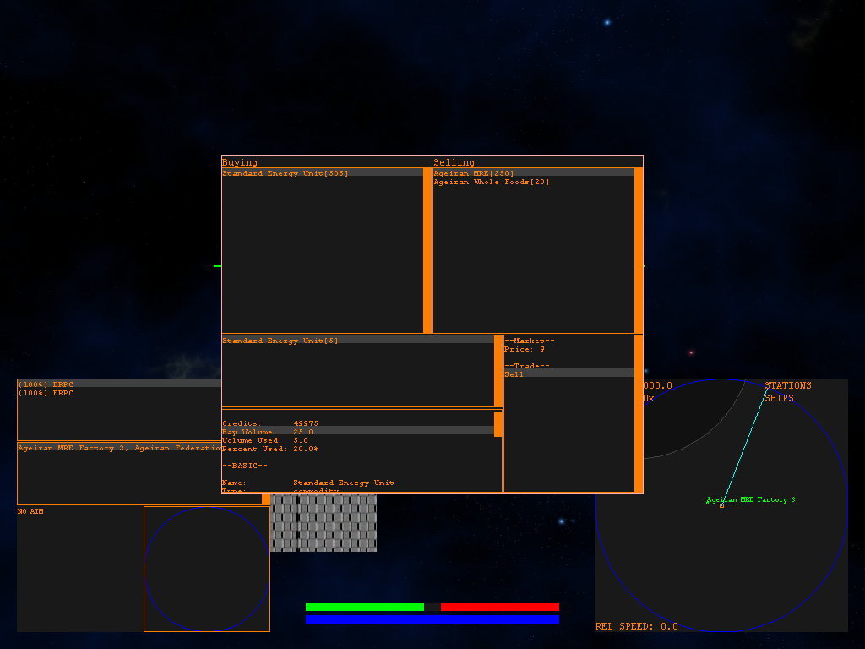
To sell your energy units, click on the standard energy units in your ship's cargo, which is in the middle panel. Then click sell, and enter the quantity to sell.

Repeat until bored! Remember, you have real competition. Those NPCs you see flying around are persistent, and keep going about their routines even when you are in another system. In this living world, prices will fluctuate due to trade, and you are in direct competition with every NPC trader in the universe!

Exploring The World

High Albedo has lots of systems to explore. You can move between systems in 2 ways.
- Flying through jumpholes.
- Using a jumpdrive.

Since you don't have a jumpdrive yet, you'll need to use the jumphole network. If you had a jump drive, you just order your ship to jump from the property window.

HINT: Jump drives consume lots of fuel. The property window will only show you systems in jump range.

You can use your property window to fly to jumpholes by issuing the 'Move to Position' command. Alternatively, you can find a jumphole on the overview and fly to it manually. Once at a jumphole, you literally just fly into it.

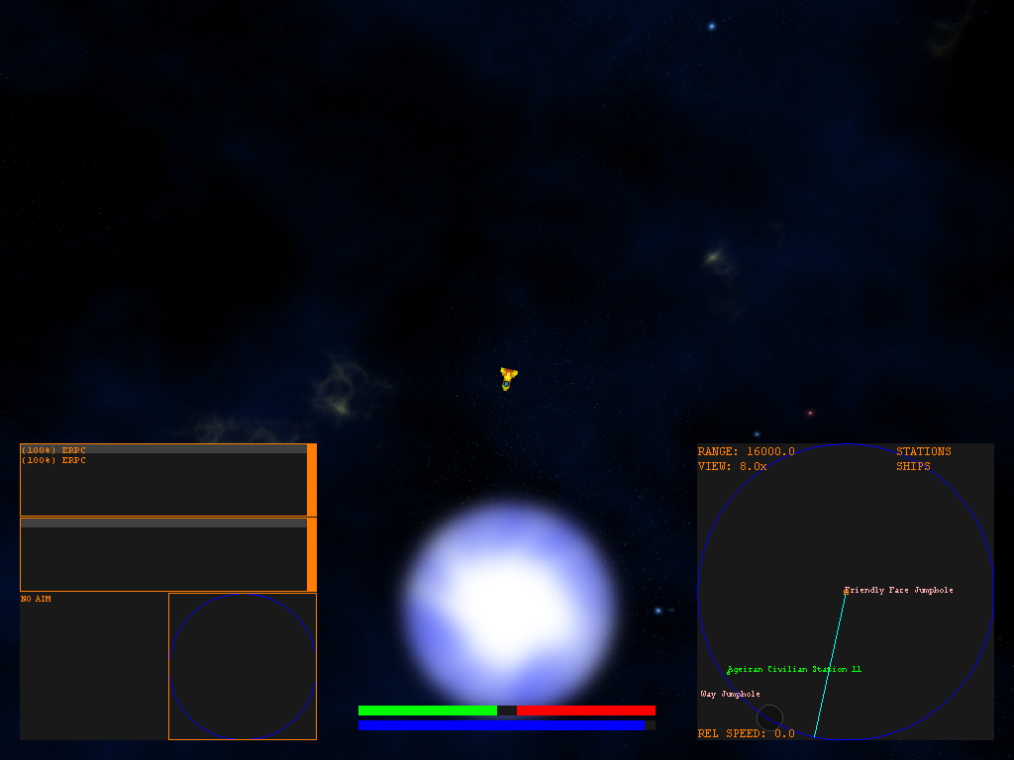
Of course, you might want to see where you are in the grand scheme of the universe. A map view is provided and can be reviewed by pressing M while in free flight. The map will only
show systems you, or one of your ships, have visited.

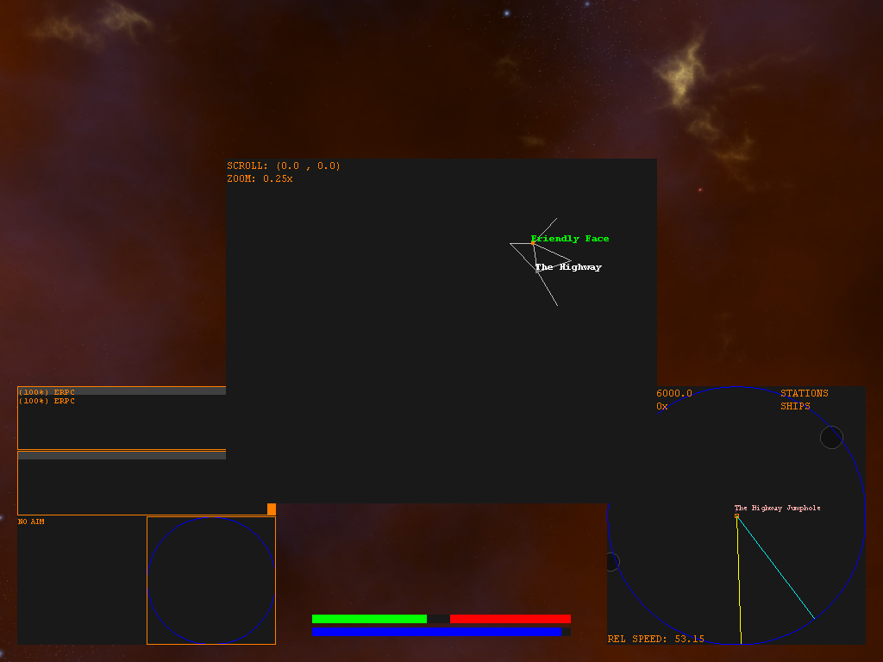
There are lots of factions in this game, and you might want to check your reputation. Pressing L in free flight brings up the standings window. Note that you can gain reputation by completing missions for a faction and by destroying enemies of the faction.

Factions that are neutral will offer you missions, but not rumors. Friendly factions will offer both missions and rumors. Hostile factions will offer neither and will probably attack you, and certainly won't let you dock at their stations.

